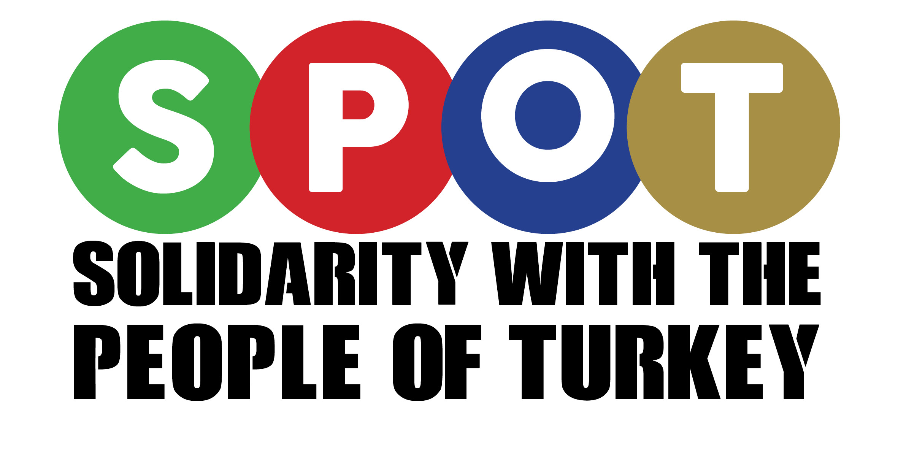
MOTION
TO AFFILIATE TO SOLIDARITY WITH THE PEOPLE OF TURKEY (SPOT)

We [INSERT NAME OF ORGANISATION/GROUP] note:
- The Turkish government is cracking down on all elements of democracy (including the free press, the independent judiciary, and freedom of expression) following the attempted anti-government coup in June 2016. Since then, the ruling party (AKP) and its President (Recep Tayyip Erdogan) declared a state of emergency, allowing this government to strengthen the arbitrary attacks on fundamental freedoms in the country and engage in outright war against the Kurdish people.

- Since June 2016, more than 50,000 Turkish citizens have been arrested and around 100,000 civil servants have been dismissed from their jobs. Under the state of emergency, the government has shut down more than 170 news organizations, some 1,500 NGOs, and jailed at least 245 journalists since the failed coup attempt – most without any due process.

- The Kurdish people have been at the fore of attacks since the attempted coup. Aggressive military operations by Turkey have caused destruction and huge loss of life in Kurdish towns and cities within Turkey. More recently, this war on the Kurds has reached a new level with Turkey’s unprovoked attack on Afrin (a Kurdish town in Syria near the Turkish border).

- The State of Emergency has been used as a means for depriving workers of basic rights and flouting health and safety at a time when the trade unions and their members are also under severe attack. Laws banning strikes and protests by organised sectors are a regular occurrence, even as workplace deaths increase.

- Women’s rights are also being attacked, particularly through religious policies, with the President going as far as to declare that gender equality “is against human nature”. For example, the government backs strict limits on access to abortion and is making it increasingly difficult for women to participate in public life. Violence against women in the country is also rife and judicial processes are rigged in favour of perpetrators, who regularly escape punishment.

- As Turkey heads towards a dictatorship, standing up for democracy is not just in the interests of the people of Turkey, it is also essential for the future peace, security and democracy of Europe and the Middle East.

We believe:
- Turkey is undergoing a critical period in its history and there is an urgent need to act to support and strengthen the fight for democratic rights and freedoms and put an end to the breaches of human rights across the country.

- There is a long tradition of joint working between the Turkish and Kurdish communities, progressive individuals and campaigning organisations in London, not least trade unions and academics.

- Together we must join forces so that we maximise our reach and effectiveness when standing up for the fundamental rights of all minorities, working people and human rights for all.

- SPOT (and the Turkish and Kurdish community more broadly) are valuable partners who have been actively supporting the struggle of the working class in the UK against austerity and increasing hardship faced by indigenous communities and migrants in the UK.

- It is essential that we actively work with SPOT to build international solidarity with democratic and progressive organisations in Turkey.
We resolve:
- To speak out against attacks on democratic freedoms in Turkey.
- To affiliate to Solidarity with the People of Turkey (SPOT) and publicise its initiatives to our membership.
- To pay for tickets and transport for __ delegates and to send our union banner to SPOT’s annual conferences.

- To support the work done by SPOT, including attending meetings, rallies, delegations and fundraising events.

SOLIDARITY WITH THE PEOPLE OF TURKEY AFFILATION FORM
Please complete all the details below and return with the donation fee to
SPOT, 22 Moorefield Road, London, N17 6PY

Trade Union/Organisation:__________________________________________________
Contact Person: Secretary/Chair/Treasurer/Other (please circle and specify):
Name: ________________________________ Position: _________________
Address: _______________________________________________________________
_________________________________________________________________
Postcode: ________________ Tel: _______________________________
Fax: ____________________ E-mail: ________________________

Affiliation Rates
Local Organisations (inc. TU Branches) £50
Regional Organisations £100
National Organisations:
- Less that 50,000 members - £120
- 50-100,000 members - £150
- 100-500,000 members - £250
- 500-1 million members - £350
- 1 million plus members - £450

How to pay
We enclose cheque/postal order, payable to Solidarity with the People of Turkey (SPOT), for:
- Local/Branch £50
- Region £100
- National £120 / £150 / £250 / £350 / £450
- Plus a donation to SPOT of £ ______ (donations help SPOT sustain and expand our crucial activities)

Alternatively, do a bank transfer to below:
Account name: Solidarity with the People of Turkey (SPOT)
Account Number: 20384900
Sort code: 60-83-01

